Instrumentation Workshop – Best instruments for the future neutron facility HBS
In recent years various projects work on developing powerful accelerator-driven neutron sources based on low energy nuclear reactions using high current proton beams . Such HIgh Current Accelerator-based Neutron Sources (HiCANS) aim to be the next generation neutron user facilities standing out by highly competitive instrument performance, cost-efficiency, and easy access. At the Jülich Centre for Neutron Science (JCNS) of Forschungszentrum Jülich, the project of a High Brilliance neutron Source (HBS) explores the possibilities and technical feasibility of such a novel neutron source in detail. To obtain high brilliance neutron beams the HBS releases neutrons from tantalum targets that are irradiated by pulsed proton beams with an energy of 70 MeV, a peak current of 100 mA and an average power of up to 100 kW. Different target stations receive pulses of different pulse lengths and repetition rates, e.g. 24 and 96 Hz, matched to the requirements of the hosted instruments. The neutron spectrum is shifted to the thermal neutron regime by moderator-reflector assemblies, which yield a brightness of 10¹³ n cm⁻² s⁻¹ sr⁻¹ Å⁻¹. Each target station can host up to 12 instruments using individual (cold) moderators and beamlines optimised to use the neutrons provided most efficiently.
A group of instrument scientists and users from Germany and European countries were invited for a series of workshops held between June 9 to June 13, 2022 at the MLZ in Garching to discuss the suite of instruments at the target stations of the future HBS HiCANS facility and their potential performance. The workshops started with an overview and current status of the HBS project and its technical parameters. Each day addressed a specific instrument class: diffractometers, instruments for large scale structures, spectrometers as well as imaging and neutron analytics instruments.
The first workshop presented various neutron diffractometers as e.g. a time-of-flight engineering diffractometer, a disordered materials diffractometer, a thermal powder diffractometer, a single crystal diffractometer, a macromolecular diffractometer, an elastic diffuse scattering spectrometer and a polarised diffuse neutron spectrometer for the HBS. While most diffractometers use the whole pulse of the 96 Hz target station adapting the instrument length (of 20 to 85 m) to the needed resolution, the thermal powder diffractometer and the engineering diffractometer use pulse shaping and wavelength frame multiplication to reach high resolution and sufficient bandwidth. The brilliance transfer between source and sample can be optimized using focussing guide systems, with the single crystal diffractometers utilizing the Selene optics concept. For the various instruments presented, such concepts allow to deliver competitive neutron fluxes at the sample position. As an example, in case of the elastic diffuse scattering spectrometer proposed by W. Schweika (JCNS), such an instrument would have a neutron flux of 2·10⁸ n s⁻¹ cm⁻² at the sample position similar to the CORELLI instrument at SNS.
At the second workshop, instruments for large scale structures as SANS and reflectometers were discussed. SANS instruments for high throughput, polarized SANS and grazing incidence SANS were presented. An interesting concept of a VSANS instrument with a vertical configuration was presented by V. Pipich (JCNS), which would allow to measure gravity induced structures and combine SANS and VSANS focusing options without any gravity effects. U. Rücker (JCNS) and A. Glavic (PSI) described various options for specular and off-specular time-of-flight reflectometers. Using the focussing SELENE optics a universal reflectometer with two beam paths for high brilliance and high intensity option was described by A. Glacic delivering a neutron flux of up to 10⁸ n s⁻¹ cm⁻² at the sample position.
A suite of spectrometers was discussed at the third workshop covering all energy regions of interest. To reach ultimate energy resolution, S. Pasini (JCNS) and C. Franz (JCNS) presented concepts for neutron spin echo spectrometers using the classical spin echo design to enable Fourier times of several hundreds of ns and a MIEZE instrument to combine spin echo and strong magnetic fields. The layout of a backscattering instrument at HBS was described by R. Zorn (JCNS). Based on the FARO concept an energy resolution of 6 μeV with a flux at sample position of 2·10⁷ n s⁻¹ cm⁻² could be achieved. Another instrument presented was a high energy direct geometry crystal monochromator spectrometer comparable to the PANTHER spectrometer at ILL. J. Voigt (JCNS) proposed indirect geometry spectrometers making use of the prismatic focusing effect, which has been evolved from multiplexing TAS secondary spectrometers and has been applied recently to the spallation source instruments BIFROST and MUSHROOM. For direct geometry time-of-flight spectrometers, N. Violini (JCNS) outlined a cold and thermal ToF spectrometer. In particular the cold chopper spectrometer benefits from the well adapted pulse length and repetition rate of the 96 Hz target station yielding a neutron flux of 4·10⁵ n s⁻¹ cm⁻² at 5 Å at an elastic energy resolution δE/E=1.5 %.
The last day of the workshop was devoted to imaging and neutron analytics instruments. Here M. Strobl (PSI) and N. Kardjilov (HZB) outlined the possibilities for cold, thermal and fast/epithermal neutron imaging stations at HBS. E. Vezhlev suggested a Neutron Depth Profiling instrument for the HBS. In addition, E. Mauerhofer (JCNS) gave an overview of prompt gamma neutron activation analysis (PGNAA) instruments to be used for environmental and cultural heritage applications.
Between 15 and 25 experts and users each day participated in the discussions either in person at the MLZ in Garching or virtually via videoconference. Intensive discussions each day gave valuable input by the community on the requirements and expressed the interest for the HBS instrumentation suite. It was highly appreciated that with the potential neutron intensity at the HBS targets versatile and competitive instrument will be available for the user community as well as industry when HBS will be realized. The result of the discussions at the workshop will be reflected in the Technical Design Report on the HBS instrumentation suite of, which is currently in preparation.

T. Gutberlet, J. Voigt (JCNS)
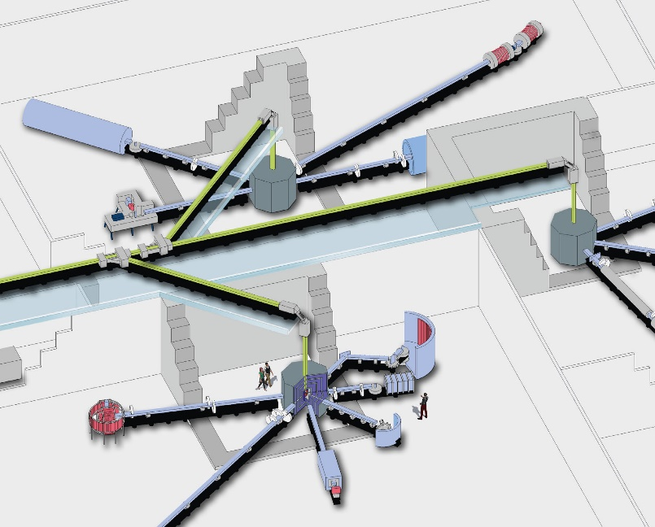
An artist view of instruments at the HBS target stations.
Copyright: Forschungszentrum Jülich

